**Key Features**

PRO Ultimate

Series

512GB

Capacity

200MB/s Read Speed

130MB/s Write Speed

Spend more time creating and less time saving with read and write speeds up to 200/130 MB/s¹ when using Samsung USB readers.  
  
• Whether you’re using a DSLR camera or a PC, count on the PRO Ultimate for compatibility. **⁴**• Designed to survive the rough and tumble of field work, the PRO Ultimate has built-in protection from elements like water and heat.⁵-¹²  
  
• Save every second in mere minutes with storage capacities ranging from 64GB to 512GB.

Storage

**64GB**

$15.99- Current Price$19.99- original price

**Save $4.00**

**128GB**

$14.99- Current Price$25.99- original price

**Save $11.00**

**256GB**

$24.99- Current Price$52.99- original price

**Save $28.00**

**512GB**

$54.99- Current Price$89.99- original price

**Save $35.00**

**VIP Advantage**

**VIP Advantage membershipLearn more**

* 2 Year Samsung Care+ (without Theft and Loss)
* Exclusive Discounts & Early Access

To select this option, please sign in or create a Samsung account

**Premium Benefits**

**$149.99/yr**

**Delivery & professional services**

Availability for:

96928

Delivery

**Delivery**

Not available



**In-Store Pickup**

Not available

This product is currently not available in your area.

**Choose your purchase option**

Questions? Ask a Financing Expert

**One-time Payment**

**$54.99**

**Pay in 4 Installments**

**$13.75**

**every two weeks σπ**

**One-time payment**

Pay with your credit card, debit card or a pay app. Excludes taxes and shipping.

**PRO Ultimate Full Size SDXC 512GB$54.99**

**Total**

**$54.99 $89.99- original price**

**You Saved Today$35.00**



**Log in now to earn up to 1.5% back in Samsung Rewards Points**

**Add to cart**

[**Where to buy**](https://www.samsung.com/us/computing/memory-storage/memory-cards/pro-ultimate-full-size-sdxc-512gb-mb-sy512s-am-buy)

Supported payment types:

Credit CardPayPal Venmo Checkoutamazonpaygooglepay

**Made for expert-level endeavors**

Meet the best of our best. The PRO Ultimate SD card offers our fastest speeds and high storage capacity to keep up with any endeavor. Extremely fast read and write speeds with multi-device compatibility help you power through your creative pursuits.

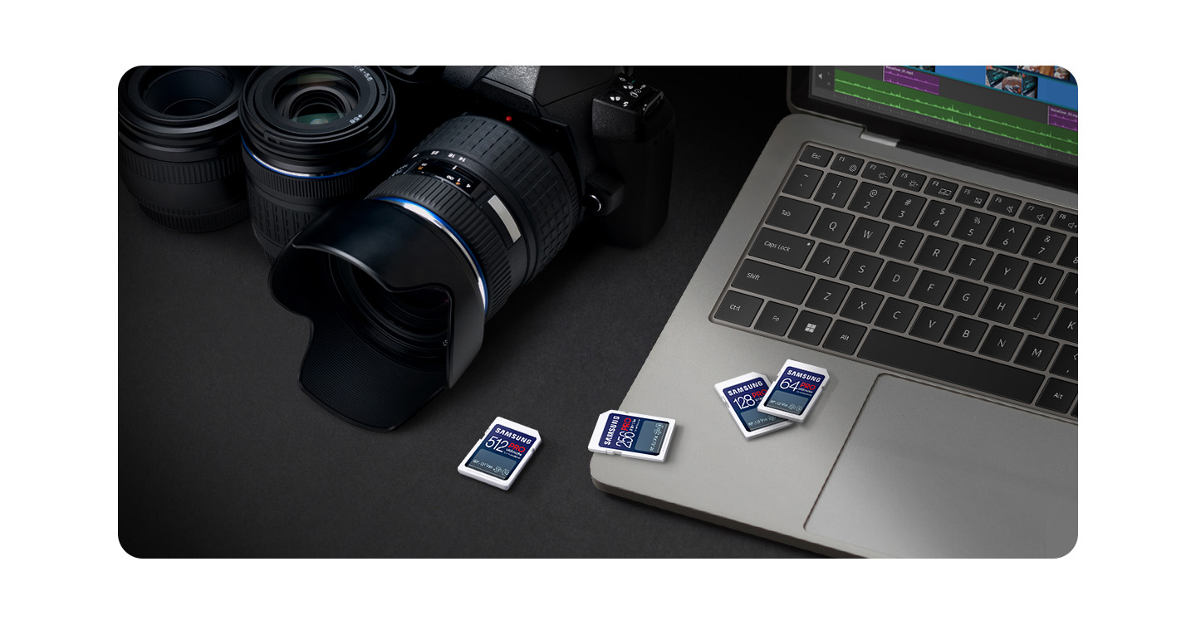

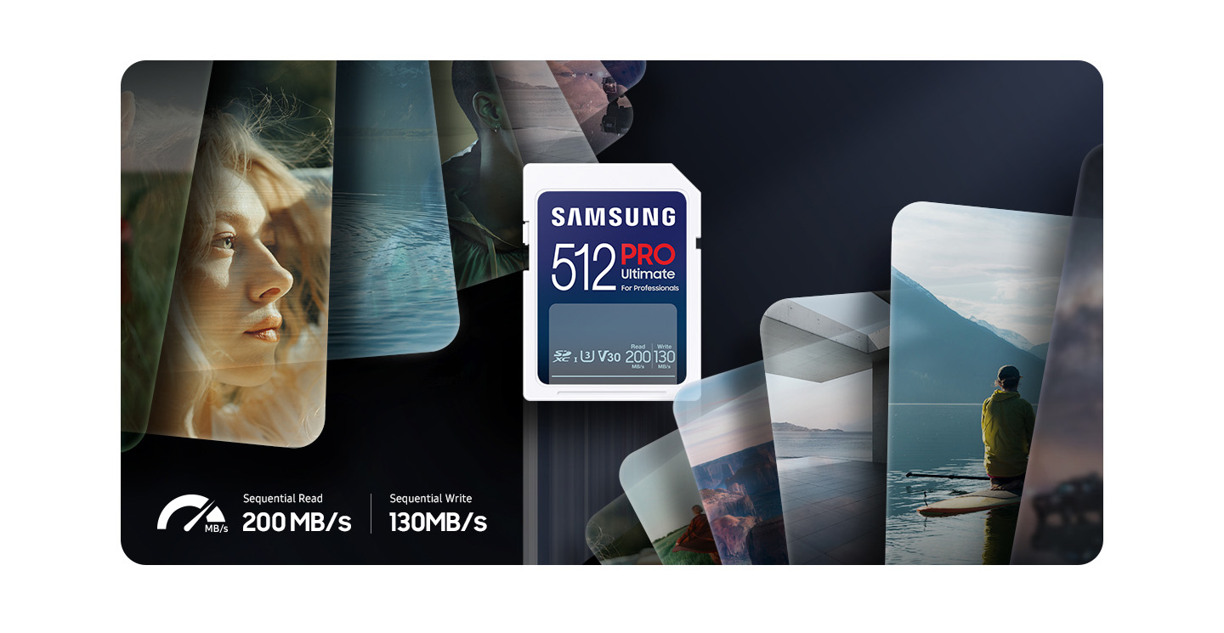

**Fast just got faster**

Read/Write Speeds up to 200/130 MB/s

The PRO Ultimate makes it easy to complete each task. Spend more time creating and less time saving with read and write speeds up to 200/130 MB/s¹ when using Samsung USB readers. It also features state-of-the-art U3 and V30 ratings² with A2 performance³ that helps with fast loading and 4K UHD video capture.

*¹The foregoing read and write speeds are based on tests conducted under controlled conditions. Actual speeds may vary depending upon card capacity. Stated performance was achieved by using PRO Ultimate microSD cards with Samsung readers.  
²UHS Speed Class 3 designates a performance option designed to support 4K UHD video recording with enabled UHS host devices. UHS Video Speed Class 30 (V30), sustained video capture rate of 30MB/s, designates a performance option designed to support real-time video recording with UHS enabled host devices. See www.sdcard.org/consumers/speed.  
³A2 performance is 4000 read IOPS, 2000 write IOPS.*



**Adapts to every need**

Extensive Compatibility

Whether you’re using a DSLR camera or a PC, count on the PRO Ultimate for extensive compatibility⁴. It a true team player when it comes to heavy-duty application usage or file-saving—and can be used with action cams and drones, too.